PES University — Dept. of CSE-AIML
Lab 1: Requirements Engineering & UML Use-Case Modelling
Blood Bank Inventory & Emergency Donor Matcher
Problem Statement #12 — Healthcare & Telemedicine
NAME : VINAY M RAMPUR SRN: PES1UG24AM455 CLASS - H
Assignment Submission — All Deliverables
1. Requirements Table (5 FR + 2 NFR)
2. UML Use-Case Diagram
3. Use-Case Flow Specification

Deliverable 1: Requirements Table
Target Stakeholders / Actors: Emergency Requester, Blood Bank Manager, Eligible Donor.

Req ID | Type | Description | Priority | Acceptance Criteria | Rationale
FR-001 | Functional | The system shall cross-reference emergency blood unit requests against real-time blood bank inventory and broadcast SMS alerts to compatible donors within a 10 km radius. | High | Pass: Compatible donors notified within 30 seconds of emergency flag; Fail: Incompatible blood group alerted. | Core requirement for handling critical shortages.
FR-002 | Functional | The system shall allow the Blood Bank Manager to log new blood donations, including the component type, blood group, and collection date. | High | Pass: A new unit is successfully saved to the inventory ledger and visible on the manager's dashboard. | Essential for real-time stock management.
FR-003 | Functional | The system shall allow an Emergency Requester to submit a blood request specifying the required blood group, component type, and urgency level. | High | Pass: The request is logged in the system with a 'Pending' status and timestamp. | Necessary to initiate the emergency matching workflow.
FR-004 | Functional | The system shall automatically flag blood components that are approaching the end of their shelf lives. | Medium | Pass: The system highlights expiring units on the manager's dashboard 48 hours prior to expiry. | Ensures safe monitoring of blood component shelf lives.
FR-005 | Functional | The system shall allow eligible donors to register their profiles, blood groups, and update their current geo-location. | Medium | Pass: A donor's profile update successfully saves the new geographic coordinates to the database. | Required to enable accurate geo-targeted emergency notifications.
NFR-001 | Performance & Security | The inventory ledger must maintain strict transactional consistency, preventing simultaneous allocation of the same blood bag. | High | Pass: Benchmarking tests confirm target latency and security standards under simulated peak load. | Ensures critical data integrity and prevents life-threatening allocation errors.
NFR-002 | Performance | The system's geo-targeting query shall identify eligible donors within a 10 km radius in under 3 seconds. | High | Pass: Database logs show the spatial query execution time is consistently < 3 seconds. | Guarantees swift system responses during emergency shortages.

Deliverable 2: UML Use-Case Diagram
System: Blood Bank & Emergency Matcher System
Actors: Blood Bank Manager, Emergency Requester, Eligible Donor
Relationships: «include» — Process Blood Match includes Broadcast SMS Alerts (always executed as part of matching). «extend» — Process Blood Match extends to Submit Emergency Request when inventory is insufficient (optional/conditional escalation path).

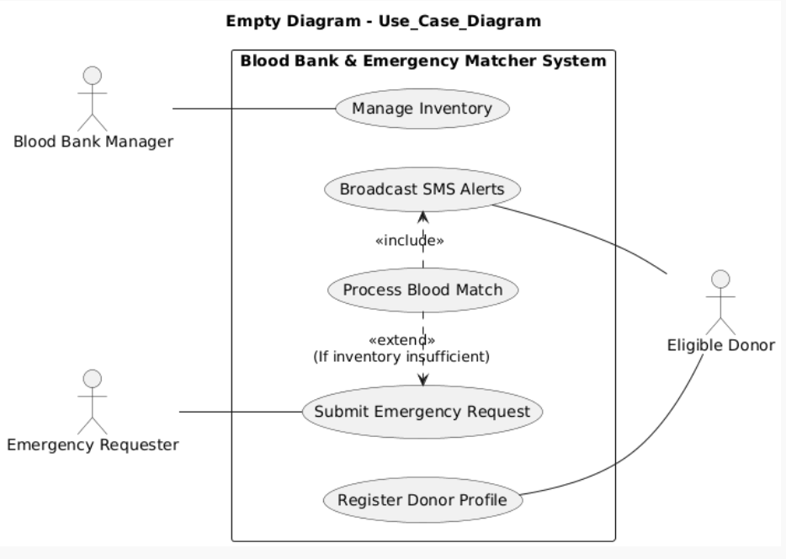

Deliverable 3: Use-Case Flow Specification
Use Case: Process Blood Match
Use Case ID: UC-03
Primary Actor: Emergency Requester
Supporting Actors: Blood Bank Manager, Eligible Donor
Related Requirements: FR-001 (SMS broadcast to compatible donors), FR-003 (submit emergency request), NFR-002 (geo-targeting < 3s)
Preconditions
• The Emergency Requester has an active account and is authenticated in the system.
• The blood bank inventory ledger is populated with current, valid stock records.
• At least one Eligible Donor profile exists with a registered blood group and geo-location.
Postconditions
• Success: A compatible blood unit is reserved for the requester, and/or eligible donors within a 10 km radius have been notified via SMS.
• Failure: The request is logged with a status indicating unmatched/insufficient inventory for manual follow-up by the Blood Bank Manager.
Main Success Scenario
1. The Emergency Requester selects "Submit Emergency Request" and enters the required blood group, component type, and urgency level.
2. The system validates the input and logs the request with a "Pending" status and timestamp (FR-003).
3. The system automatically triggers "Process Blood Match" and cross-references the request against the real-time inventory ledger.
4. The system finds a compatible, sufficient blood unit in stock and reserves it, updating the inventory ledger transactionally (NFR-001).
5. The system includes "Broadcast SMS Alerts" to notify the Blood Bank Manager that a unit has been allocated.
6. The system updates the request status to "Matched" and displays a confirmation to the Emergency Requester.
7. Use case ends successfully.
Alternate Flow — A1: Inventory Insufficient (extends to Submit Emergency Request escalation)
4a. At step 4, the system determines that no compatible unit meets the request (insufficient inventory).
4a1. The system «extends» the flow to re-invoke "Submit Emergency Request" as an escalated, system-flagged shortage case.
4a2. The system queries eligible donor profiles for compatible blood group and geo-location within a 10 km radius (NFR-002).
4a3. The system includes "Broadcast SMS Alerts" and notifies all matching Eligible Donors within 30 seconds (FR-001).
4a4. If a donor responds and donates in time, the Blood Bank Manager logs the new unit; the request is re-matched and the use case resumes at step 4.
4a5. If no donor responds within the defined window, the request remains "Pending – Critical" and is flagged on the Blood Bank Manager's dashboard for manual intervention.

